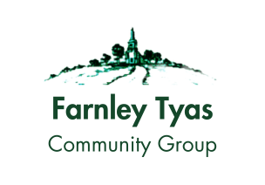
Farnley Tyas Community Group
Agenda
Wednesday February 5th, 2025, Farnley Tyas Bowling Club

Agenda Number | Item | Lead
1 | Welcome and Introductions | NH-W
2 | Apologies | SM
3 | Minutes of the last meeting (AGM November 2024) | NH-W
4 | Matters Arising (not on the Agenda) | NH-W
5 | Represent the interests and concerns of village residents to the local authorities and other stakeholders
 | - Council updates | RB/BA
 | - Traffic Calming | NW
 | - Neighbourhood watch | NW
6 | Organize and support various initiatives and projects that benefit the village and its residents
 | - Church updates | KH
 | - Knit and Natter | LH/NW
 | - WI | FH
 | - Garden Gang | RW/FH
 | - Farnley Walkers | JD/NH
 | - Farnley Readers | NH-W
 | - Farnley Flutter | FH
 | - Village Fete | DC
 | - Farnley Tyas Arts and Cinema Club | RW
7 | Provide a platform for dialogue, cooperation, and mutual assistance among the residents
 | - Open Forum -what matters to you? | ALL
 | Encourage the participation and involvement of all residents in the group's activities and decision-making
 | - January Committee Meeting Update | NH-W
 | - Finance Update | NH-W
 | - Community Fundraising Scheme | NH-W
 | - Newsletter | NH-W
 | - Supporting local businesses | NH-W
8 | Preserve and celebrate the cultural, historical, and natural heritage of the village
 | - Field Lane | FLUG Rep
 | - Yew Trees Farm | KB/NH-W
 | - Tidy Tyas | NH-W
 | - Farnley in Bloom | RW/NH-W
9 | AOB
 | Date and Time of next meeting  Wednesday 5th March, 2025, 7.15pm Farnley Tyas Bowling Club | SM

